**MicroStrategy Quick Guide:**

**Fix the “Export to Excel” Error when using Internet Explorer**

**ITU Data Mart Support Group, Reporting Support**

# Issue

Some users may experience an error when exporting to Excel using Internet Explorer.

The issue presents itself when you export to Excel and open the file (without saving it first). The exported file will open with a warning that the file is unsafe.

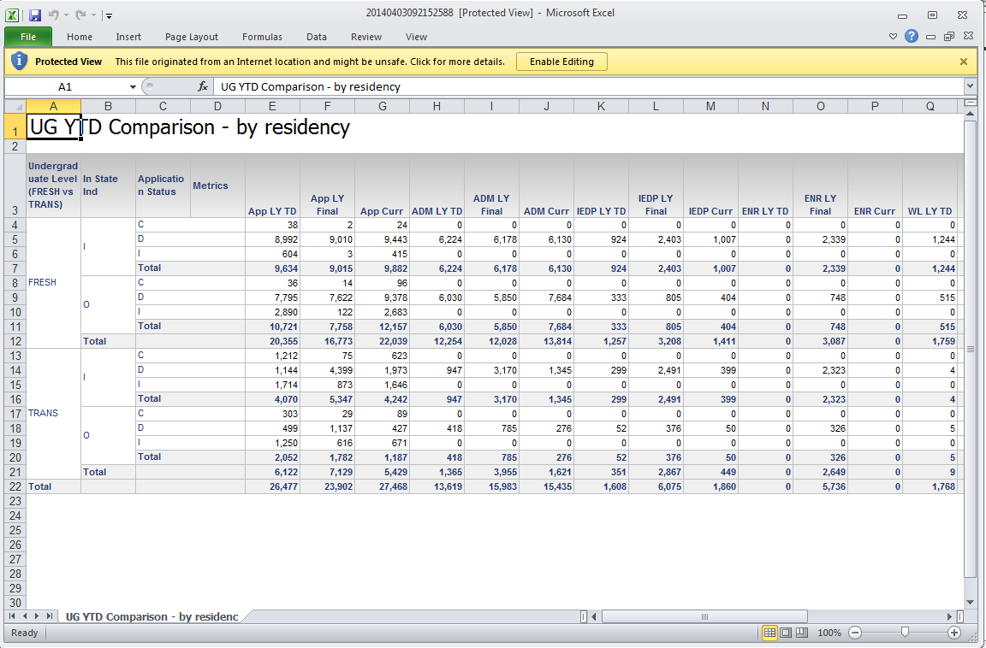

When you click “Enable Editing” from the warning window, the data in the worksheet deletes itself and you instead see a login page.

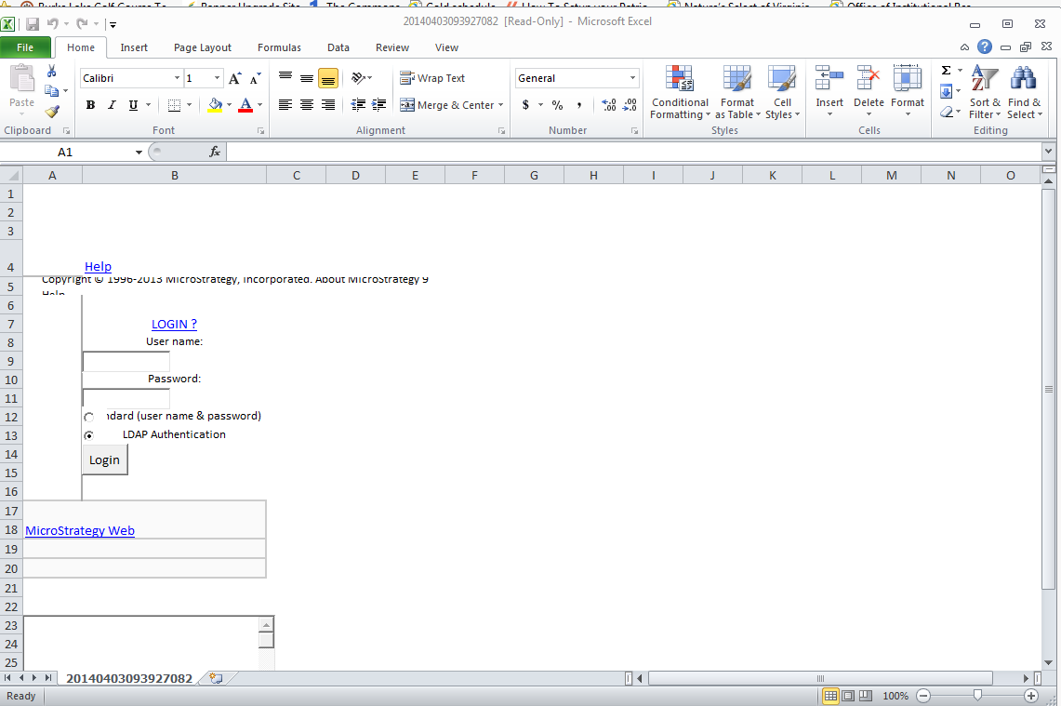

## Solution

To fix this issue, add the MicroStrategy URL to your list of trusted sites in Internet Explorer.

1. Open Internet Explorer
2. Open the Internet Options

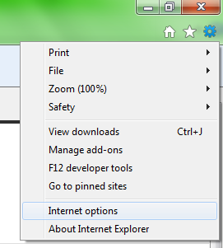

1. Click the tab titled Security > Local intranet > Sites
2. Click Advanced
3. Enter the URL for MicroStrategy <https://inveniopws.gmu.edu> and click Add

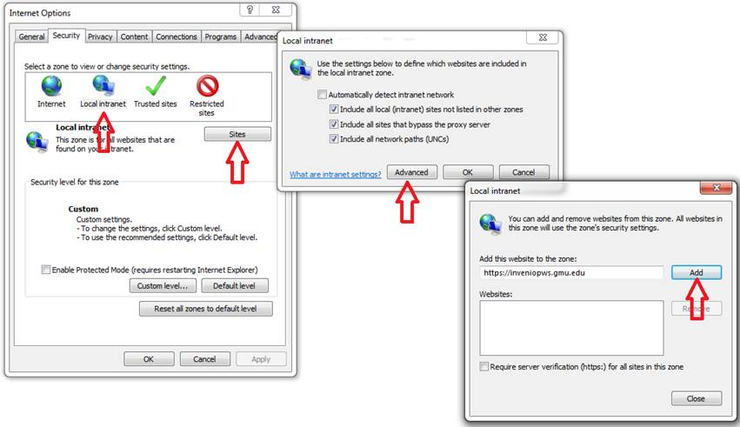

You should now be able to export to Excel without issue.