Webex Interview Email Templates

Email from Search Committee Coordinator to Candidate:
Please include this language in the email sent to the candidate to inform them of the interview format, as well as the scheduled interview date and time. It is highly recommended to test Webex with the candidate prior to the day of the interview.

To: Candidate
CC: Committee Chair
From: Search Committee Coordinator
Subject: Information for Meeting with [Mason Dept Name]

Your interview will be conducted via videoconference from your PC or Mac computer on [date and time] using web browser-based videoconferencing tool Webex Meetings. You do not need to have a Webex account to participate. Below is the link you will use to join the meeting. When connecting to the meeting follow these instructions: https://collaborationhelp.cisco.com/article/en-us/njmhfgbb

Link: [insert Webex meeting link]

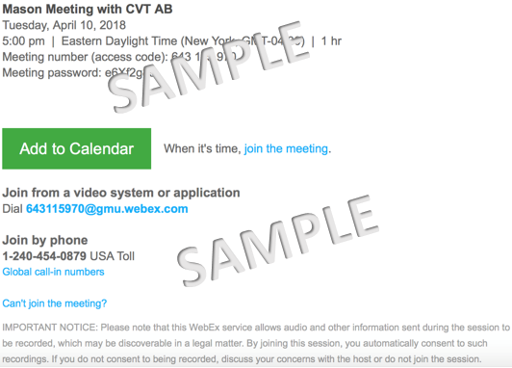
(Optional: You are required to complete a live test before the interview. The Webex test should take no more than 10 minutes and should be from the same computer and location you plan to participate from for the interview. I am available to test [available dates and times]. Please email [coordinator’s email address] or call 703-993-[ext.] to schedule your test.)

Sincerely,
Email from Coordinator to Candidate regarding scheduled Webex test
To: Candidate
CC:
From: Admin/Coordinator
Subject: Test Scheduled for [date and time]

I have scheduled a Webex test on [date] (EST) at [time]. Please use the Webex link provided in a previous email to join the meeting. We will test the audio and video quality in preparation for your interview. If you have any questions or problems joining the meeting, please reply to this email or call (703)993-[ext.].

Sincerely,

